

Name of Student: Advait Dhanawade | PRN: 25070122023
Subject: Programming with Java
ASSIGNMENT No: 1
TITLE: Develop an application based on Java environment setup, JDK/JRE/JVM, variables, methods and constructors. and demonstrate the implementation of the concepts through suitable examples.

Problem Statement
Develop an application based on Java environment setup, JDK/JRE/JVM, variables, methods and constructors. and demonstrate the implementation of the concepts through suitable examples.
Learning Objectives
Understand the theoretical concepts, implement them in Java programs, analyze outputs, and apply the concepts to solve practical programming problems.
Theory
Java environment setup, JDK/JRE/JVM, variables, methods and constructors. forms an important component of Java programming. Students should understand the underlying concepts, architecture, advantages, use cases, and implementation methodology. The exercise should focus on understanding the design principles, coding practices, execution flow, and practical applications of these concepts in software development. Detailed study should include syntax, APIs, execution process, and real-world applications.

Questions
1. Explain the main concept used in Java environment setup, variables and methods.
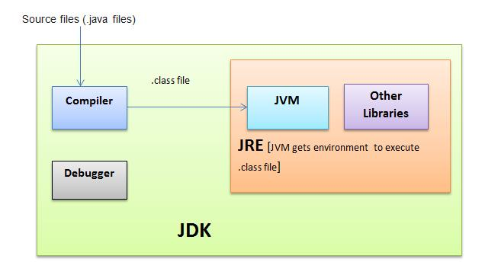
- Environment Setup: The core concept is Platform Independence ("Write Once, Run Anywhere"). Setting up the environment involves installing the JDK (Java Development Kit), which provides the compiler and the JRE (Java Runtime Environment) with the JVM (Java Virtual Machine). Configuring system variables like JAVA_HOME and PATH ensures the operating system can execute Java commands globally.

- Variables: The core concept is Strong Typing and State Management. Variables act as named memory locations that hold data representing the state of an object or application. Java requires explicit declaration of a variable's data type, ensuring strict memory allocation and type safety.

- Methods: The core concept is Modularity and Behaviour. Methods encapsulate specific blocks of code to perform a single task. They define the behaviour of objects and allow complex programs to be broken down into smaller, manageable, and logical components.

2. What are the advantages of using Java variables and methods?
Advantages of Variables:
- Type Safety: Strict type checking at compile-time prevents unexpected runtime errors.
- Memory Efficiency: Allows developers to choose specific primitive types (like int vs. byte) to optimize memory usage.
- Data Reusability: Temporarily stores values that can be reused and manipulated throughout the program's execution.
Advantages of Methods:
- Code Reusability (DRY Principle): Write the code once and call it multiple times, eliminating redundancy.
- Maintainability: Easier to debug and update code when logic is isolated into specific methods.
- Readability: Simplifies complex code logic, making the main program flow easier to understand.
- Encapsulation: Helps hide complex implementation details from the user, exposing only necessary inputs and outputs.

3. How can this implementation be improved?

4. What are the real-world applications?
Real-World Applications of Java:
- Android Mobile Applications: Java is a foundational language for building native Android OS apps.
- Enterprise Web Applications: It is used extensively in backend systems for banks, e-commerce platforms, and large corporations, often using frameworks like Spring.
- Big Data Technologies: Core framework components of Big Data ecosystems like Apache Hadoop and Apache Kafka are written in Java.
- Internet of Things (IoT) & Embedded Systems: It is used in smart appliances, wearables, and enterprise-level network devices.
- Scientific and Financial Applications: It is preferred for systems requiring high security, multithreading, and fast processing, such as high-frequency trading platforms.

…

